**MENSTRUAL CYCLE**

Reproductive organs inside a woman's body.

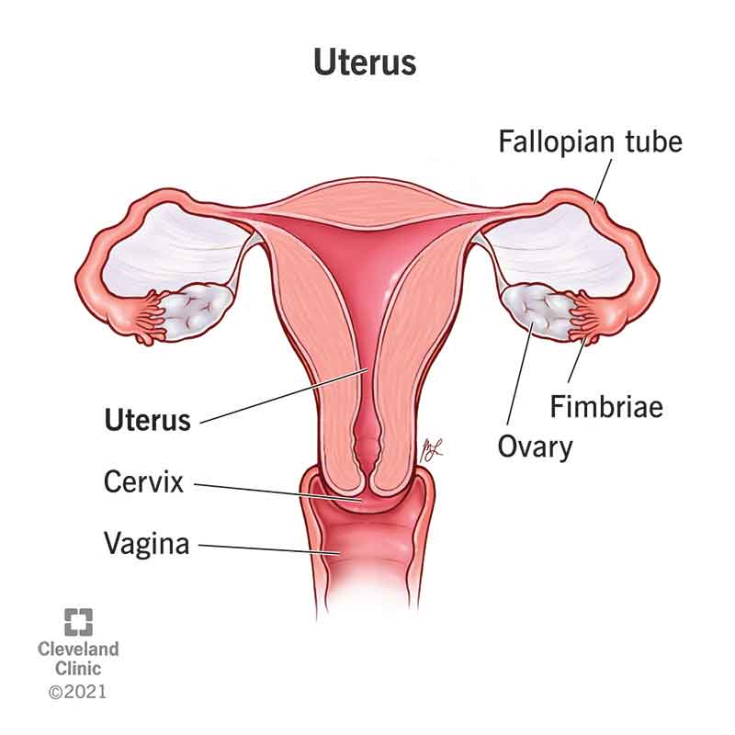

* 2 ovaries – where eggs are stored, developed and released
* the womb (uterus) – where a fertilized egg implants and a baby develops
* the fallopian tubes – two thin tubes that connect the ovaries to the womb
* the cervix – the entrance to the womb from the vagina
* the vagina

The menstrual cycle - is a series of natural changes in hormone production and the structures of the uterus and ovaries of the female reproductive system that makes pregnancy possible.

## Breakdown of hormones in the menstrual cycle and their functions.Follicle stimulating hormone

* Follicle-stimulating hormone is produced by the pituitary gland.
* It regulates the functions of both the ovaries and the testes.
* Lack or insufficiency of it can cause infertility in both men and women
* Follicle-stimulating hormone is one of the gonadotropic hormones, the other being the luteinizing hormone, and both are released by the [pituitary gland](https://elara.care/culture/female-health-glossary/) into the blood stream. Follicle-stimulating hormone is essential to [pubertal development](https://elara.care/female-reproductive-health/first-period-stories/). In women,
* This hormone stimulates the growth of ovarian follicles in the ovary before the release of an egg and it also increases a type of oestrogen.

## Oestrogen

Oestrogen is one of the main female sex hormones. While both women and men produce oestrogen.

Functions in controlling puberty and strengthening of bones. Having too much or too little oestrogen can cause a range of [different medical conditions](https://www.medicalnewstoday.com/articles/323280).

**There are three oestrogens – oestrone, oestradiol and oestriol – the most potent of which is oestradiol.**

* **Oestradiol**is produced in women of childbearing age, mostly by the ovaries.
* **Oestriol** is the main oestrogen produced during pregnancy, mostly in the placenta.
* **Oestrone**, produced by the adrenal glands and fatty tissue, is the only type of oestrogen produced after menopause.

## Oestradiol

Oestradiol is a steroid hormone made from [cholesterol](https://elara.care/physical-health/lipid-profile-test-or-lipid-panel-testing-your-cholesterol/) and is the strongest of the three naturally produced oestrogens.

It is the main oestrogen found in women and has many functions, although it mainly acts to mature and maintain the female reproductive system.

* A natural increase in blood oestradiol concentrations during the menstrual cycle causes an egg to mature and be released.
* Another important role . is to thicken the lining of the uterus so that the egg can implant if it becomes fertilised.
* It promotes the development of breast tissue and increases both bone and cartilage density.
* In premenopausal women ,it is mostly made by the ovaries. Oestradiol levels vary throughout the monthly menstrual cycle, being highest at ovulation and lowest at menstruation.
* Oestradiol levels in women reduce slowly with age, with a large decrease occurring at [menopause](https://elara.care/female-reproductive-health/menopause-weight-gain/) when the ovaries ‘switch off’.
* In pregnant women, the placenta also produces a lot of oestradiol, especially towards the end of the pregnancy.

**Men also produce oestradiol**; however, the amounts produced are much lower than in women. Within the testes, some testosterone is changed into oestradiol and this oestradiol is essential for the production of sperm. In both sexes, oestradiol is also made in much smaller amounts by fat tissue, the brain and the walls of blood vessels.

**Luteinising hormone**

* Luteinising hormone, like a follicle-stimulating hormone, is a gonadotrophic hormone produced and released by cells in the anterior pituitary gland.
* It is crucial in regulating the function of the testes in men and ovaries in women.
* **In women, the luteinising hormone carries out different roles in the two halves of the menstrual cycle.**In weeks one to two of the cycle, luteinising hormone is required to stimulate the ovarian follicles in the ovary to produce the female sex hormone, oestradiol.
* Around day 14 of the cycle, a surge in luteinising hormone levels causes the ovarian follicle to tear and release a mature oocyte (egg) from the ovary, a process called ovulation.
* For the remainder of the cycle (weeks three to four), the remnants of the ovarian follicle form a corpus luteum.

The luteinising hormone stimulates the [corpus luteum](https://elara.care/culture/female-health-glossary/) to produce progesterone, which is required to support the early stages of pregnancy if fertilisation occurs.

## Progesterone

Progesterone belongs to a group of steroid hormones called progestogens. It is mainly secreted by the corpus luteum in the ovary during the second half of the menstrual cycle.

**It plays important role in the menstrual cycle and in maintaining the early stages of pregnancy.**

During the menstrual cycle, when an egg is released from the ovary at ovulation (approximately day 14), the remnants of the ovarian follicle that enclosed the developing egg form a structure called the corpus luteum. This releases progesterone and, to a lesser extent, oestradiol.

**Progesterone prepares the body for pregnancy in the event that the released egg is fertilised.**

**If the egg is not fertilised**, the corpus luteum breaks down, the production of progesterone falls and a new menstrual cycle begins.

**If the egg is fertilised**, progesterone stimulates the growth of blood vessels that supply the lining of the womb (endometrium) and stimulates glands in the endometrium to secrete nutrients that nourish the early embryo.

Progesterone then prepares the tissue lining of the uterus to allow the fertilised egg to implant and helps to maintain the endometrium throughout pregnancy.

During the early stages of pregnancy, progesterone is still produced by the corpus luteum and is essential for supporting the pregnancy and establishing the placenta. Once the placenta is established, it then takes over progesterone production at around weeks 8-12 of pregnancy.

**During pregnancy**, progesterone plays an important role in the development of the foetus; it stimulates the growth of maternal breast tissue; prevents lactation; and strengthens the pelvic wall muscles in preparation for labour.

The level of progesterone in the body steadily rises throughout pregnancy until labour occurs and the baby is born.

Although the corpus luteum in the ovaries is the major site of progesterone production in humans, progesterone is also produced in smaller quantities by the ovaries themselves, the adrenal glands and, during pregnancy, the placenta.

A woman’s menstrual cycle is divided into four phases:

* menstrual phase
* follicular phase
* ovulation phase
* luteal phase

The length of each phase can differ from woman to woman, and it can change over time.

**Menstrual phase**

The menstrual phase is the first stage of the menstrual cycle. It’s also when you get your period.

This phase starts when an egg from the previous cycle isn’t fertilized. Because pregnancy hasn’t taken place, levels of the hormones estrogen and progesterone drop.

The thickened lining of your uterus, which would support a pregnancy, is no longer needed, so it sheds through your vagina. During your period, you release a combination of blood, mucus, and tissue from your uterus.

You may have period symptoms like these:

* cramps .
* tender breasts
* bloating
* mood swings
* irritability
* headaches
* tiredness
* low back pain

On [average](http://www.soc.ucsb.edu/sexinfo/article/menstrual-cycle), women are in the menstrual phase of their cycle for 3 to 7 days.

## Follicular phase

The follicular phase starts on the first day of your period (so there is some overlap with the menstrual phase) and ends when you ovulate.

It starts when the hypothalamus sends a signal to your pituitary gland to release [follicle-stimulating hormone (FSH)](https://www.healthline.com/health/fsh). This hormone stimulates your ovaries to produce around 5 to 20 small sacs called follicles. Each follicle contains an immature egg.

Only the healthiest egg will eventually mature. (On rare occasions, a woman may have two eggs mature.) The rest of the follicles will be reabsorbed into your body.

The maturing follicle sets off a surge in estrogen that thickens the lining of your uterus. This creates a nutrient-rich environment for an embryo to grow.

The [average follicular phase Trusted Source](https://www.ncbi.nlm.nih.gov/pmc/articles/PMC2834565/) lasts for about 16 days. It can range from 11 to 27 days, depending on your cycle

**Ovulation phase**

Rising estrogen levels during the follicular phase trigger your pituitary gland to release [luteinizing hormone (LH)](https://www.healthline.com/health/lh-blood-test). This is what starts the process of [ovulation](https://www.healthline.com/health/womens-health/what-is-ovulation).

Ovulation is when your ovary releases a mature egg. The egg travels down the fallopian tube toward the uterus to be fertilized by sperm.

The ovulation phase is the only time during your menstrual cycle when you can get pregnant. You can tell that you’re ovulating by symptoms like these:

* a slight rise in [basal body temperature](https://www.healthline.com/health/pregnancy/basal-body-temperature)
* thicker discharge that has the texture of egg whites

Ovulation happens at around day 14 if you have a 28-day cycle — right in the middle of your menstrual cycle. It lasts about 24 hours. After a day, the egg will die or dissolve if it isn’t fertilized.

**Luteal phase**

After the follicle releases its egg, it changes into the [corpus luteum](https://www.healthline.com/health/womens-health/corpus-luteum). This structure releases hormones, mainly progesterone and some estrogen. The rise in hormones keeps your uterine lining thick and ready for a fertilized egg to implant.

If you do get pregnant, your body will produce human chorionic gonadotropin (hCG). This is the hormone [pregnancy tests](https://www.healthline.com/health/hcg-in-urine) detect. It helps maintain the corpus luteum and keeps the uterine lining thick.

If you don’t get pregnant, the corpus luteum will shrink away and be resorbed. This leads to decreased levels of estrogen and progesterone, which causes the onset of your period. The uterine lining will shed during your period.

During this phase, if you don’t get pregnant, you may experience symptoms of [premenstrual syndrome (PMS)](https://www.healthline.com/health/premenstrual-syndrome). These include:

* bloating
* breast swelling, pain, or tenderness
* mood changes
* headache
* weight gain
* changes in sexual desire
* food cravings
* trouble sleeping

The luteal phase lasts for 11 to 17 days. The [average lengthTrusted Source](https://www.ncbi.nlm.nih.gov/pmc/articles/PMC4436586/) is 14 days

Any of these things can alter your menstrual cycle:

* [**Birth control**](https://www.healthline.com/health/birth-control-pills)**.** The birth control pill may make your periods shorter and lighter. While on some pills, you won’t get a period at all.
* [**Pregnancy**](https://www.healthline.com/health/pregnancy)**.**Your periods should stop during pregnancy. Missed periods are one of the most obvious [first signs](https://www.healthline.com/health/pregnancy/early-symptoms-timeline) that you’re pregnant.
* [**Polycystic ovary syndrome (PCOS)**](https://www.healthline.com/health/polycystic-ovary-disease)**.** This hormonal imbalance prevents an egg from developing normally in the ovaries. PCOS causes irregular menstrual cycles and missed periods.
* [**Uterine fibroids**](https://www.healthline.com/health/uterine-fibroids)**.** These noncancerous growths in your uterus can make your periods longer and heavier than usual.
* [**Eating disorders**](https://www.healthline.com/nutrition/common-eating-disorders)**.**Anorexia, bulimia, and other eating disorders can disrupt your menstrual cycle and make your periods stop

DAY 1-7 uterus lining breaks down and the menstruation occurs

DAY 8-11 the lining of the womb thickens in preparation for the egg

Day 12-17 ovulation occurs usually on 14th day

DAY 18-25 if fertilization has not taken place the corpus luteum fades away

DAY 26-28 the uterine lining detaches leading to menstruation